**Problem Set 3**

**EP 960**

**Structural Equation Modeling**

For this assignment, please conduct the following set of analyses:

1. Read in the data. For these data, missing is blank in the .csv file. R will automatically insert NA for missing data that is blank. There is no recoding that you need to do.

2. Run the full SEM model in the figure using ML under listwise deletion. Report results.

3. Rerun the initial model adding FIML for the analysis of missing data. Report on any changes you observe in fit statistics, estimates, and standard errors compared to Step 2.

4. Rerun the initial model using MLR instead of ML but keeping FIML. Report changes you observe f in fit statistics, estimates, and standard errors from Step 3.

5. Rerun the initial model keeping MLR but replacing FIML with multiple imputation using predictive mean matching. Report any changes in fit statistics, estimates, and standard errors compared to Step 4.

6. Rerun the initial model with WLSMV and multiple imputation using predictive mean matching. Report any changes in fit statistics, estimates, and standard errors compared to Step 5.

1. Model

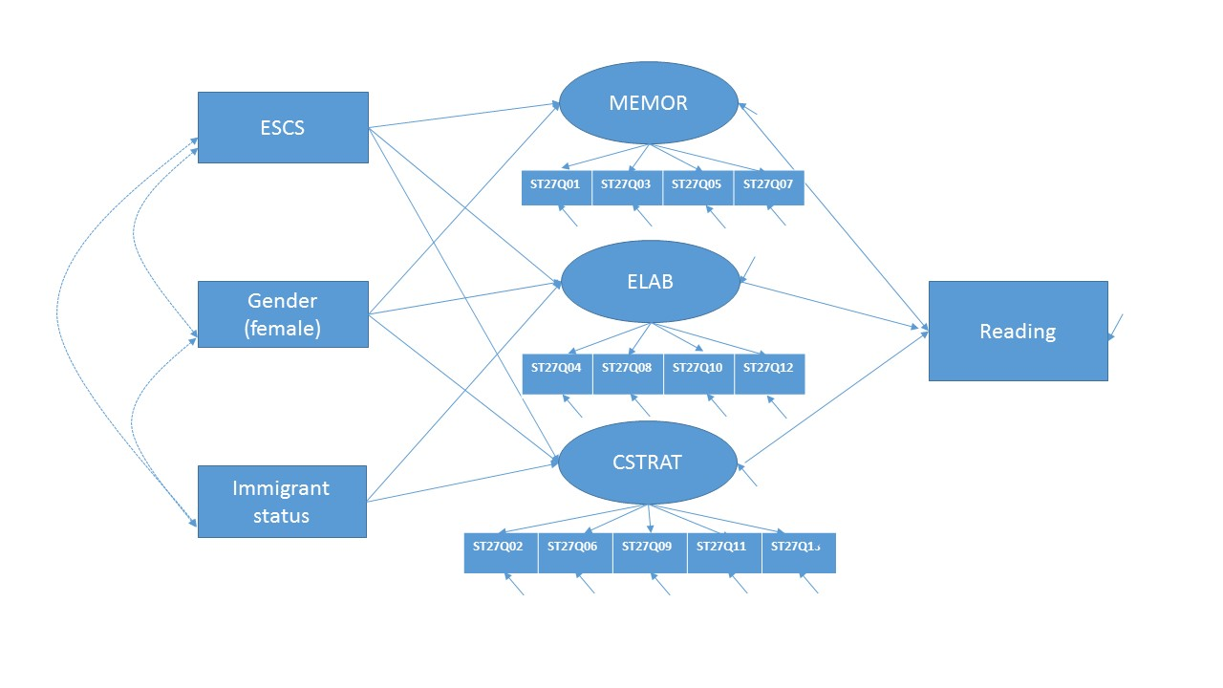

1. Variable description

ESCS: The PISA index of economic, social and cultural status (ESCS) was derived from the following three indices: highest occupational status of parents (HISEI), highest educational level of parents in years of education according to ISCED (PARED), and home possessions (HOMEPOS). The index of home possessions (HOMEPOS) comprises all items on the indices of WEALTH, CULTPOSS and HEDRES, as well as books in the home recoded into a four-level categorical variable (0-10 books, 11-25 or 26-100 books, 101-200 or 201-500 books, more than 500 books).

The PISA index of economic, social and cultural status (ESCS) was derived from a principal component analysis of standardized variables (each variable has an OECD mean of zero and a standard deviation of one), taking the factor scores for the first principal component as measures of the index of economic, social and cultural status.

The final values on the PISA index of economic, social and cultural status (ESCS) have an OECD mean of 0 and a standard deviation of 1.

Gender: it is coded to have 1 if female and 0 if male.

Immig: The index on immigrant background (IMMIG) is coded to have 1 if either (2) second-generation students (those born in the country of assessment but whose parents were born in another country) or (3) first-generation students (those born outside the country of assessment and whose parents were also born in another country), and to have 0 if native students (those students born in the country of assessment, or those with at least one parent born in that country; students who were born abroad with at least one parent born in the country of assessment are also classified as ‘native’ students).

Approaches to learning

How students approach learning is based on student responses in ST27 and measured through the following three indices:

memorisation (MEMOR), elaboration (ELAB) and control strategies (CSTRAT).

The index of memorisation (MEMOR) was derived from the frequency with which students did the following when they were studying: i) try to memorise everything that is covered in the text; ii) try to memorise as many details as possible; iii) read the text so many times that they can recite it; and iv) read the text over and over again.

The index of elaboration (ELAB) was derived from the frequency with which students did the following when they were studying: i) try to relate new information to prior knowledge acquired in other subjects; ii) figure out how the information might be useful outside school; iii) try to understand the material better by relating it to my own experiences; and iv) figure out how the text information fits in with what happens in real life.

The index of control strategies (CSTRAT) was derived from students’ reports on how often they did the following statements: i) when I study, I start by figuring out what exactly I need to learn; ii) when I study, I check if I understand what I have read; iii) when I study, I try to figure out which concepts I still haven’t really understood; iv) when I study, I make sure that I remember the most important points in the text; and v) when I study and I don’t understand something, I look for additional information to clarify this.

Higher values on the index indicate higher importance attached to the given strategy.

ST27Q01-ST27Q13

Q27 When you are studying, how often do you do the following? (Please tick only one box in each row) Almost never(1)/ Sometimes(2)/ Often(3)/ Almost always(4)

1) When I study, I try to memorize everything that is covered in the text.

2) When I study, I start by figuring out what exactly I need to learn.

3) When I study, I try to memorize as many details as possible.

4) When I study, I try to relate new information to prior knowledge acquired in other subjects.

5) When I study, I read the text so many times that I can recite it.

6) When I study, I check if I understand what I have read.

7) When I study, I read the text over and over again.

8) When I study, I figure out how the information might be useful outside school.

9) When I study, I try to figure out which concepts I still haven’t really understood.

10) When I study, I try to understand the material better by relating it to my own experiences.

11) When I study, I make sure that I remember the most important points in the text.

12) When I study, I figure out how the text information fits in with what happens in real life.

13) When I study and I don’t understand something, I look for additional information to clarify this.